

**Junior Texture Artist**

Brown Bag Films are looking to recruit for the position of Junior Texture Artist.

**Job Description:**

* Work with Project's Lead Texture Artist/TD on production assets.
* Create Photo real and stylised texture maps
* Create Efficient/optimal UV layout for texture painting.

**Applicants should have the following experience:**

* A full working knowledge of Photoshop, or similar paint package, is vital.
* Strong visual skills - a good eye for detail, scale, composition, colour and form.
* Knowledge of Maya, 3DS Max and/or rendering software a plus
* Diploma or Degree in CG or Animation is required.

Showreels or online links to past work are welcome .

**Start date : August 2011**

|  |
| --- |
|  |

About Brown Bag Films

Brown Bag Films® are an award winning animation studio producing high quality 3D animation for the international market. With headquarters in Dublin City and an office in Los Angeles, their short film *Give Up Yer Aul Sins* was nominated for an Academy Award® in 2002 and this was repeated in 2010 when *Granny O’Grimm* was also nominated for an Oscar. Brown Bag Films have worked on a number of high profile international projects with recent productions including *Olivia*, *Noddy, Doc McStuffins* and *The Octonauts.* For further information, please visit our website [www.brownbagfilms.com](http://www.brownbagfilms.com)

Please send cv and completed Application Form to [jobs@brownbagfilms.com](mailto:jobs@brownbagfilms.com)

*Only applications containing completed Application Form and CV will be accepted, incomplete applications are deemed as not received and as such will not be considered.

**JOB APPLICATION: Junior Texture Artist**

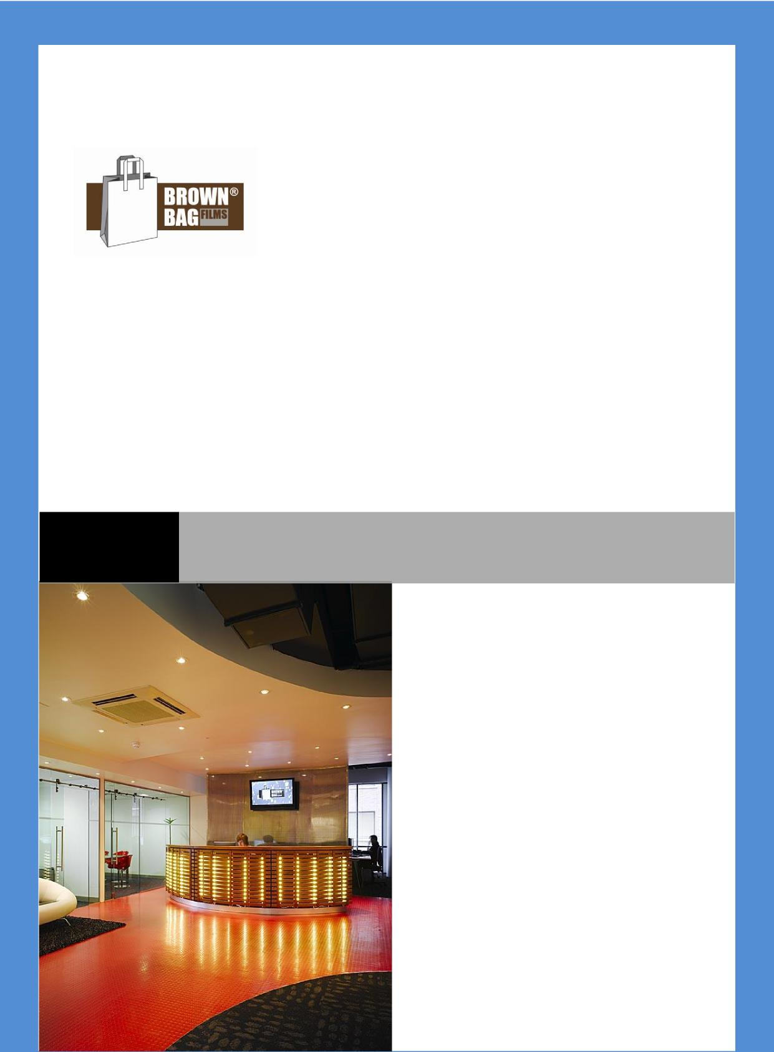

**Name:** :

**Personal Information**





**Address:** :

**Contact Phone number:** :

**Email:** : **Website**:

**Available to work from** :

|  |
| --- |
| **What are you like to work with?** |

**Work History**

**What was your best job and why?**

|  |
| --- |
| **What software do you have a strong working knowledge of?** |



**About You**

**What do you do for fun?**



**5 words that describe you:**

**Why do you want to work for Brown Bag Films?**

|  |
| --- |
| **Who is your favourite cartoon character of all time and why?** |
| **What are your 6 favourite websites?** |

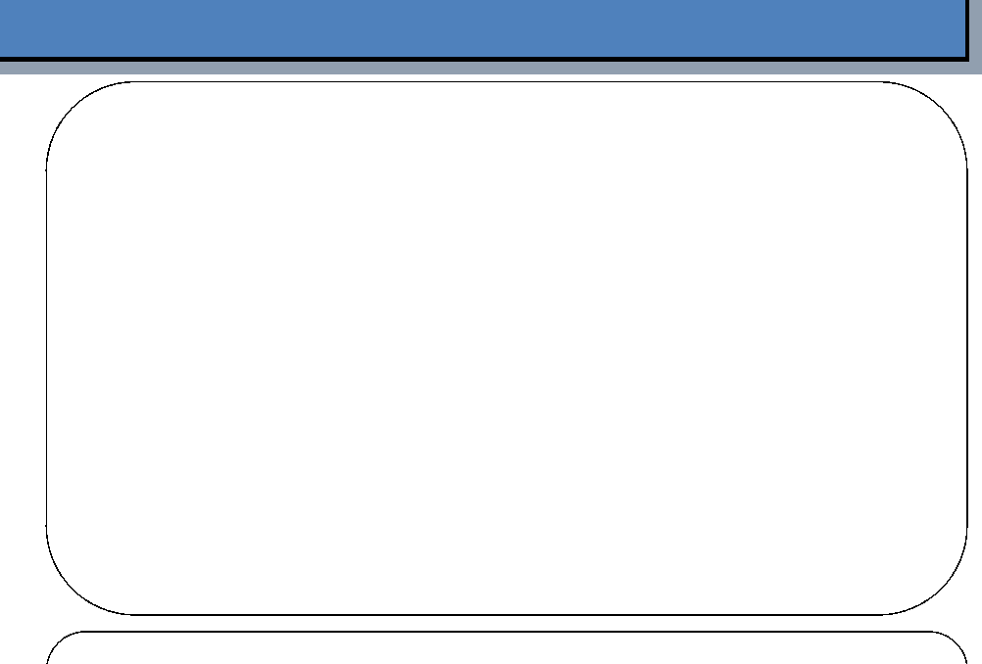

**What personal or professional achievement are you most proud of?**

**What skills do you have for this job that make you the exceptional candidate?**



|  |
| --- |
| **What are your current salary and your expected salary expectations?** |

**If we were to provide training to develop your skills further, what would you most benefit from?**



|  |
| --- |
| **Do you have anything else you would like to share with us that we haven’t asked?** |

**BBF Policy**

Our staff are central to the success of Brown Bag Films and we thank you for completing this application form and your interest in working with us.



We will never publish, share or distribute this information with any third party, it will be treated as strictly confidential.







Only applications containing CV and completed Application Form will be accepted, incomplete applications are deemed as not received and as such will not be considered. The nature of animation production means that we are not always recruiting staff. So if you

are unsuccessful for a position this time around, it does not mean that we will not have a job for you in the future. All Job applications and CV’s will be deleted or discarded after 12 months and we encourage you to update us with your CV after this time.

All enquiries about your job application should only be sent [to jobs@brownbagfilms.com](mailto:to_jobs@brownbagfilms.com) If you are called for an interview, each candidate is asked the same questions and scored against a list of criteria relevant to each job. In the event you are unsuccessful, we can



provide you with some limited feedback as to where the successful candidate scored higher. Brown Bag Films are an equal opportunity employer and are committed to a fair recruitment process.

