Overseas Animation Supervisor (India)

Jobs Description:

Brown Bag Films are seeking an Animation Supervisor to work on one of our high profile 3D TV series in India.
Experience as Animation Director/Supervisor in Long Form 3D animation Television Series is required for this position.

You will be supervising the animation production onsite in India while working closely (remotely) with our Animation Director here in Dublin.
As part of your duties you will be reporting to Brown Bag Films on a daily/weekly basis to ensure the standard and the quality of the animation is consistent.

Start Date: Immediately

Please send cv and completed Application Form to jobs@brownbagfilms.com

*Only applications containing completed Application Form and CV will be accepted, incomplete applications are deemed as not received and as such will not be considered.

JOB APPLICATION: Overseas Animation Supervisor

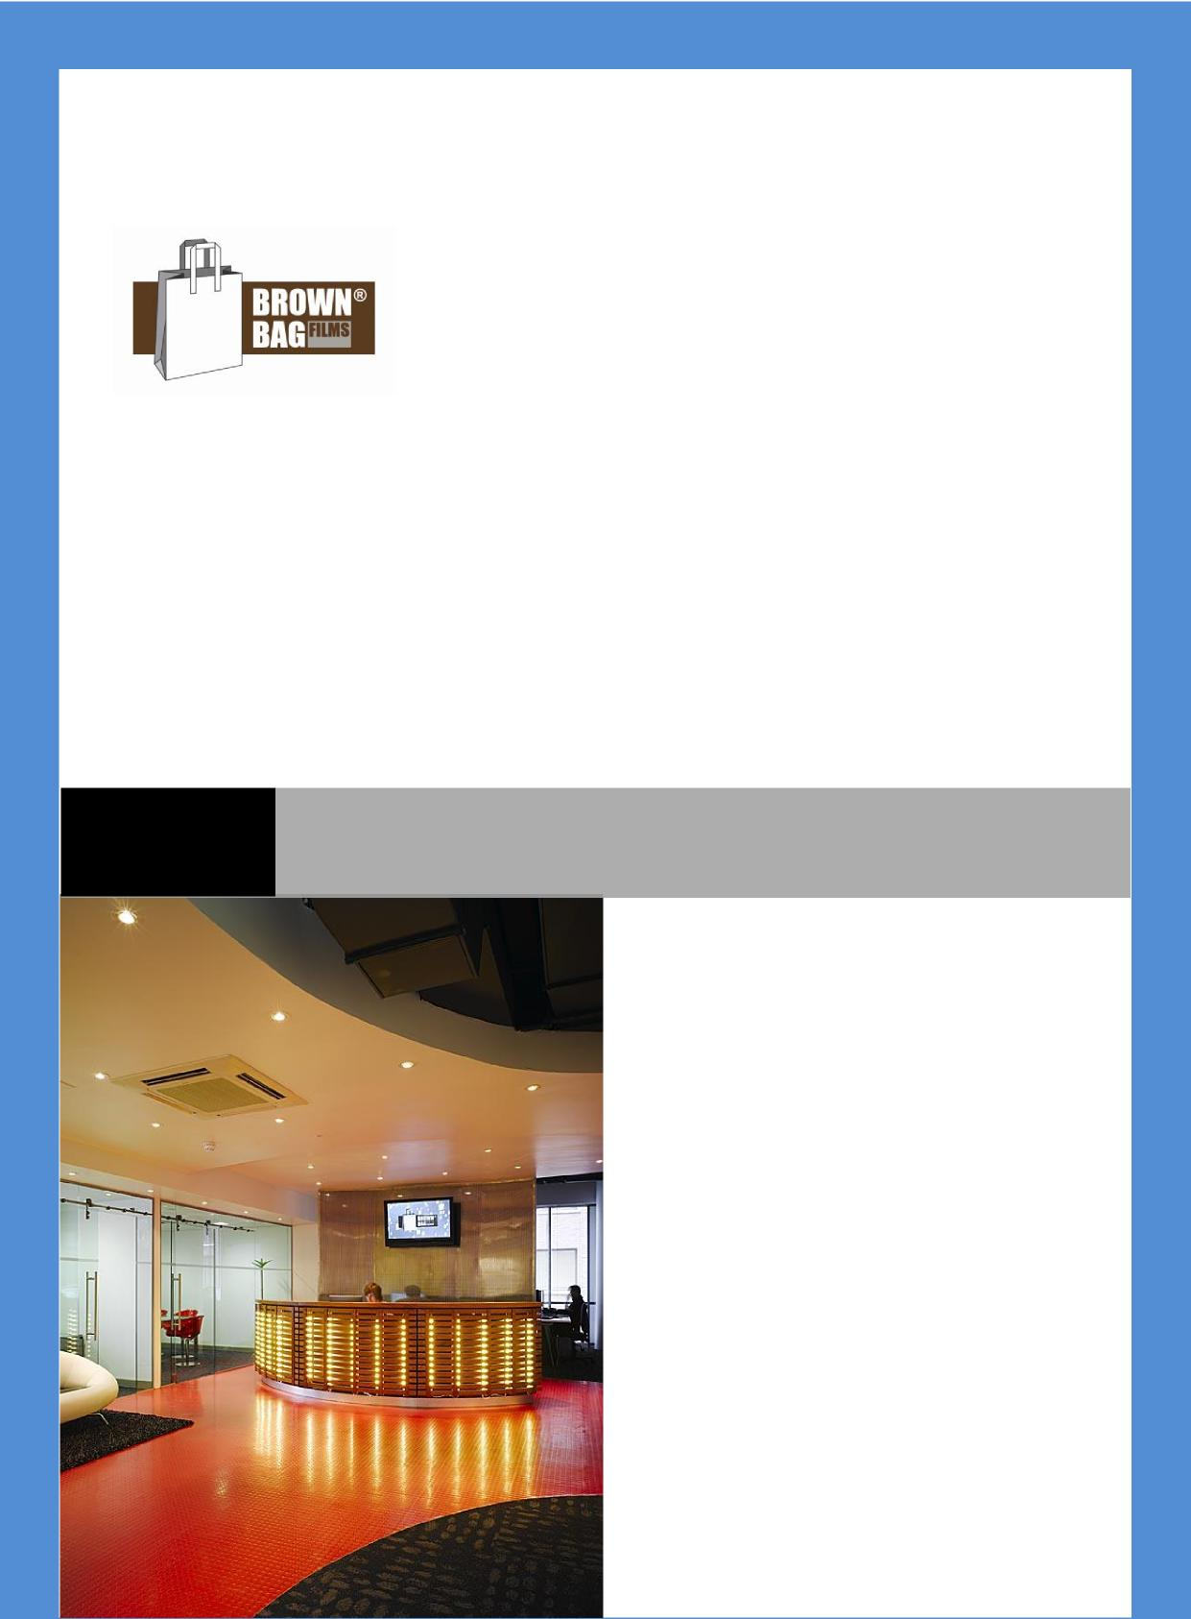

Name: :
Personal Information
Address: :
Contact Phone number: :
Email: : Website:
Available to work from :

What are you like to work with?

Work History

What was your best job and why?

What software do you have a strong working knowledge of?

About You
What do you do for fun?

5 words that describe you:
Why do you want to work for Brown Bag Films?

Who is your favourite cartoon character of all time and why?
What are your 6 favourite websites?

What personal or professional achievement are you most proud of?
What skills do you have for this job that makes you the exceptional candidate?

What are your current salary and your expected salary expectations?
If we were to provide training to develop your skills further, what would you most benefit from?

Do you have anything else you would like to share with us that we haven’t asked?

BBF Policy

Our staff are central to the success of Brown Bag Films and we thank you for completing this application form and your interest in working with us.
We will never publish, share or distribute this information with any third party, it will be treated as strictly confidential.
Only applications containing CV and completed Application Form will be accepted, incomplete applications are deemed as not received and as such will not be considered. The nature of animation production means that we are not always recruiting staff. So if you
are unsuccessful for a position this time around, it does not mean that we will not have a job for you in the future. All Job applications and CV’s will be deleted or discarded after 12 months and we encourage you to update us with your CV after this time.
All enquiries about your job application should only be sent to jobs@brownbagfilms.com If you are called for an interview, each candidate is asked the same questions and scored against a list of criteria relevant to each job. In the event you are unsuccessful, we can
provide you with some limited feedback as to where the successful candidate scored higher. Brown Bag Films are an equal opportunity employer and are committed to a fair recruitment process.

