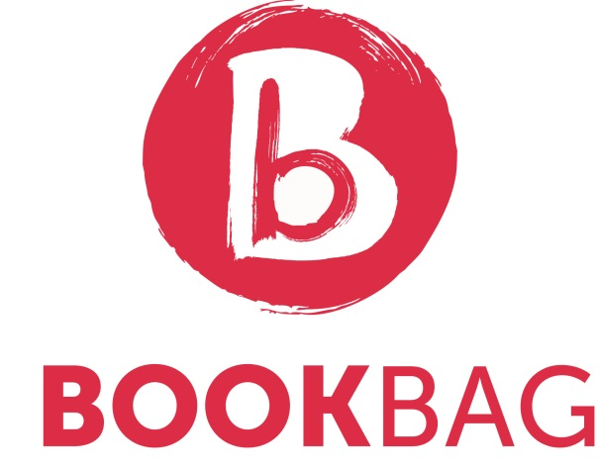

Bookbag is a children’s book gifting initiative, funded by Brown Bag Films and delivered in partnership with Children’s Books Ireland. Aimed at DEIS schools, where free books can be most needed, the Bookbag project gifts every child in chosen schools with a book to take home and keep.

On Monday 20th April, the second annual Bookbag scheme was launched at Our Lady of Victories Infants School in Ballymun. Every student in the school was given a Bookbag containing a book, posters, bookmarks and a letter from former Laureate na nÓg Niamh Sharkey to take home and keep.

All 260 students took part in a large scale Monster Doodle, encouraging creativity through illustration. A number of books were also gifted to the school library, and later this year, a special library of books will be compiled by Children’s Books Ireland for the school with the goal of helping teachers and parents discuss difficult topics with younger students through story.

As part of the project, every class in the school will be visited by an author or illustrator over the coming weeks. The overall aim of Bookbag is to encourage a reading culture among the children in the school and among their families, and to ensure that every child in the school has access to at least one book in their home.

Bookbag was initiated by picture book-maker Niamh Sharkey during her term as Laureate na nÓg (2012–2014). Niamh campaigned throughout her tenure for a universal book-gifting scheme, which would ensure that every baby born in Ireland receives the gift of a book in their first year of life. Rutland National School, local to both Children’s Books Ireland and Brown Bag Films in Dublin’s north inner city, was chosen as the first school to take part in the initiative.

Bookbag is delivered by Children’s Books Ireland in partnership with Brown Bag Films, who funds the project. Bookbag is bolstered this year by a €5,000 bursary award granted by Dublin Airport Authority at the 2014 Allianz Business to Arts Awards, where the project was nominated for ‘Best Use of Creativity in the Community’.

While Children’s Books Ireland continues to campaign for a nationwide book-gifting scheme, Brown Bag Films has dedicated funding to Bookbag for the next two years with hopes that with additional sponsors and support it could become a nationwide project.

‘We are thrilled to see this project growing and developing in its second year,’ said Elaina Ryan, Director of Children’s Books Ireland. ‘As well as making sure that every child in the school gets a book to take home and keep, and that they meet an author or illustrator in their classroom, we spend time at the beginning of the project assessing the particular needs of each school. We hope that the library of books which address difficult issues for young children will be a really important and powerful resource for both the teachers and the children at Our Lady of Victories School.’

Niamh Sharkey said “To gift a book into the hands of a child is to open the door to a lifelong love of reading. Brown Bag Films are thrilled to launch the second year of Bookbag. Our wish is that all children in Ireland should be gifted a book, an initiative that is already successfully delivered in over thirty countries worldwide. We are committed to raise awareness about book gifting and encourage other companies to join us. We hope Bookbag will grow and grow over the next few years, so more children can discover the life-changing benefits that reading can bring.’

Brown Bag Films are renowned for their 2001 Oscar-nominated short animated film Give Up Yer Aul Sins. They developed Niamh Sharkey’s book I’m a Happy Hugglewug into an animated series for Disney Junior, Henry Hugglemonster. They are also well known for high-profile international TV series’ including Disney Junior's Doc McStuffins, Octonauts and Daytime Emmy-winning Peter Rabbit.

Children’s Books Ireland’s mission is to make books a part of every child’s life. They champion and celebrate the importance of authors and illustrators and work in partnership with those who enhance children’s lives through books.

For more information contact Elaina Ryan, Director, Children’s Books Ireland
elaina@childrensbooksireland.ie / +353 (0)1 8727475
www.childrensbooksireland.ie / www.brownbagfilms.com

