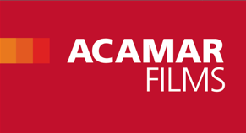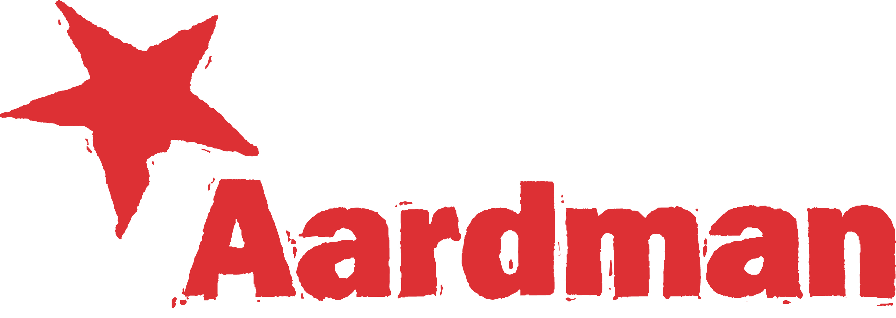­­­­

**BING GOES GLOBAL!**

**New international broadcast and licensing partners,**

**and a new global distribution partnership with**

**Aardman Animations announced**

London, 9th October 2014. London based **Acamar Films**, the independent production company and distributor behind the children’s television show **BING**, is today announcing a wide range of new international broadcast and licensing partners to follow thehugely successful UK launch of **BING** on **CBeebies** this summer.

**Acamar** and **Aardman** are also jointly this morning announcing a new global distribution partnership on **BING**  between Acamar and Aardman’s Rights and Brand Development division.

Acamar Films has announced broadcast deals for **BING** with **Australia’s ABC**, **S4C** in Wales, Irish broadcaster **RTE**, as well as **SVT**, and Danish channel **DR** across Scandinavia. The series has also sold across Eastern Europe to **Minimax**, and will reach Belgian audiences via broadcaster **VRT.** Discussions continue on a wide range of additional territories at MIPCOM.

To strengthen Acamar’s distribution of **BING** it has entered into a global distribution partnership with Aardman. The specialist team at Aardman will now handle a wide range of key territories on Acamar’s behalf with Acamar continuing to handle the countries covered by existing coproductions on Bing, as well as sales in the USA and Japan.

**BING** continues to perform strongly in the licensing market with the announcement of two new key licensees and the appointment of **Merchantwise** as licensing agent for Australia. In addition, **Egmont**, one of Europe’s leading publishers, has been appointed to develop a dedicated **BING** magazine which will launch this December in the UK, Eire, Germany, Austria, Switzerland as well as in the Nordic region and Russia. **Ravensburger** has also signed up to produce a range of **BING** themed puzzles in the UK for this Christmas. Both of these partnerships were brokered by The Licensing Company on behalf of Acamar Films.

Mikael Shields, CEO of Acamar Films and the Producer of **BING** comments:

“We’re thrilled. The response to the launch of BING on CBeebies in the UK this summer has been overwhelming and it’s exciting now to be working with our international broadcast and licensing partners to reach a global audience for our work. We honestly think the Aardman team are the best in the industry so it feels like an intelligent choice for Acamar to enlist them to help us to build on BING’s success.”

Alix Wisemen, Head of Sales and Acquisitions at Aardman comments:

“From the moment we first saw Bing we were mesmerised. It is a rare thing to find a show so meticulously executed and we are truly thrilled to have secured the rights.”

Alan Schauder, Managing Director of Merchantwise says:

“We are proud and excited to be representing Bing and can’t wait for Australian audiences to meet him for the first time. Apart from looking incredible, this show has an amazing ability to talk to pre-schoolers in a very authentic way. We have no doubt that Bing will be loved by Australian pre-schoolers and their parents for years to come.”

The launch of a range of ‘**BING** things’ has already begun. **HarperCollins** launched a new range of TV tie-in books to its existing “Classic **BING**” publishing range this week. The Acamar and TLC teams are also now working on a range of **BING** toys in collaboration with global market leader **Fisher Price** for launch in the summer of 2015.

**BING** has enjoyed a phenomenal response to the first 40 episodes which launched in June this year, across television, social media and the BBC’s iPlayer. The show now enjoys an enviable 4 slots a day Monday to Friday, increased from the previous 2 slots daily. The full 78 episode series will continue with additional debut broadcasts stretching well into 2015.

Celebrating the noisy, joyful, messy reality of everyday life when you’re a pre-schooler, **BING** stories are small but they are full of drama; micro-dramas depicting everyday events that all young children and the grown-ups in their lives will recognise. Just when **Bing** thinks he’s got the hang of life, it can swing right back and knock him over. But it’s okay - as Bing’s companion and carer Flop says: *“Never mind Bing, it’s no big thing!”*

**BING** has been adapted from the insightful books by award-winning author and illustrator Ted Dewan. The series has been meticulously developed by a hand-picked team at Acamar in partnership with leading Irish animation studio Brown Bag Films.

**For further information, please contact:**

**Monique Levine at DDA Blueprint**

Tel: + 44 (0) 20 7932 9800 or email [monique@ddablueprint.com](mailto:monique@ddablueprint.com)

**About Acamar Films:**

Acamar Films was founded in 2005 to create and produce premium quality film and television projects. Its CEO Mikael Shields has over 25 years’ experience and an international reputation for identifying, developing, financing and producing a wide range of hit film and television projects including Nick Park’s *Wallace & Gromit*, Aardman’s *Rex The Runt*, Candy Guard’s *Pond Life*, *Pingu,* *Noddy,* *Hilltop Hospital* and *Flatworld*. Prior to co-founding Acamar he has held senior management positions at the BBC, EVA Entertainment, Pearson, Atom Films and Ealing Studios.

**About Aardman Animations**

Aardman, based in Bristol (UK) co-founded and run by Peter Lord and David Sproxton, is a world leader in animation. It produces feature films, series, advertising and digital entertainment for both the domestic and international market. Their multi-award winning productions are novel, entertaining, brilliantly characterised and full of charm that reflects the unique talent, energy and personal commitment of the very special people who make up the Aardman team. The studio’s work is often imitated and yet the company continues to lead the field producing a rare brand of visually stunning and amusing independent and commercials productions. [www.aardman.com](http://www.aardman.com)

**Aardman Rights and Brand Development** are renowned for developing and building enduring character brands across all media. They specialise in marketing and realising the commercial potential of their properties in a way that celebrates and respects their intrinsic creative values. Classic brands in the portfolio include Wallace & Gromit, Shaun the Sheep, Timmy Time and Morph, while Aardman Rights has recently acquired third party representation for a number of top Children’s brands.

**About Brown Bag Films:**

Brown Bag Films® is a global leader in children’s and family entertainment. Millions of kids watch their series every day in over 150 countries. Brown Bag Films® is currently producing four of the world’s highest rated pre-school shows including ***Doc McStuffins***, ***Henry Hugglemonster***, ***Peter Rabbit***and ***Octonauts***. As well as Emmy and BAFTA nominations for its TV series, the studio has been awarded two Oscar™ nominations for its short films ***Give Up Yer Aul Sins*** (2002) and ***Granny O’Grimm’s Sleeping Beauty*** (2010). With over 20 years’ experience, Brown Bag Films® remains a creatively-owned and managed studio with headquarters in Dublin and operations in Los Angeles. For more information please visit [www.brownbagfilms.com](http://www.brownbagfilms.com)

**About The Licensing Company**

An independent global brand licensing agency formed in 1996 by Melvin Thomas and Angela Farrugia. The Licensing Company (TLC) represents some of the biggest brands in the world. Strategic, capable and connected, TLC has an unparalleled reputation for creating the most innovative, effective and successful brand extensions across a range of sectors including Fashion, Auto, Entertainment and Food & Beverage. With offices in New York, Detroit, London, Paris, Munich, Shanghai, Seoul and Tokyo, TLC boasts 40+ direct-to-retail partners, 2,000+ in store concessions, 200+ stand alone branded stores, 25+ Industry awards and over $3.8 billion in retail sales in 2012. TLC’s portfolio includes brands such as Jeep, Chrysler, Coca-Cola, Budweiser, Jelly Belly, Mercedes-Benz and Hershey’s.

**About Merchantwise**

Building and extending great brands Merchantwise is a leading brand licensing and creative marketing agency based in Melbourne Australia. Merchantwise combines insight-driven strategy with innovative and creative solutions to deliver tangible brand value for its clients. For over 15 years, Merchantwise has supported many of the world’s best loved brands across a diversity of sectors including entertainment and attractions, sports and leisure, retail and consumer products.

Brands and properties represented in the Australasian region include: Blinky Bill, The Hive, Chuggington, The Gruffalo, Strawberry Shortcake, Sonic the Hedgehog, Asterix, Jack Daniel's, M&M's, The Beatles, Live Nation, Paramount Studios, Sony Pictures, King Features and Manchester United FC.

**About Egmont Publishing**

Egmont is the UK’s top specialist children’s publisher selling almost 40 million magazines and books each year for babies to teens. The company is home to some of the world’s best loved authors, illustrators and characters such as Barbie, Thomas the Tank Engine Ben 10, Michael Morpurgo, Andy Stanton, Michelle Magorian and Lemony Snicket plus Winnie-the-Pooh, Wallace & Gromit, Tintin and Mr Men

Egmont UK is part of the Egmont Group which was founded in 1878. It is Scandinavia’s leading media group and Europe’s largest children’s publisher telling stories through books, magazines, film, TV, music, games and mobile in 30 countries throughout the world.

[www.egmont.co.uk](http://www.egmont.co.uk)

**About Mattel**

The Mattel family of companies (Nasdaq: MAT) is the worldwide leader in the design, manufacture and marketing of toys and family products. Mattel’s portfolio of best-selling brands includes Barbie®, the most popular fashion doll ever produced, Hot Wheels®, Monster High®, American Girl®, Thomas & Friends® and Fisher-Price® brands, including Little People® and Power Wheels®, MEGA® Brands, including MEGA BLOKS® and RoseArt®, as well as a wide array of entertainment-inspired toy lines. In 2013, Mattel was named one of the "World's Most Ethical Companies" by Ethisphere Magazine and in 2014 ranked No. 5 on Corporate Responsibility Magazine's "100 Best Corporate Citizens" list. With worldwide headquarters in El Segundo, Calif., Mattel’s companies employ nearly 30,000 people in 40 countries and territories and sell products in more than 150 nations. At Mattel, we are Creating the Future of Play. Visit us at [www.mattel.com](http://www.mattel.com/), [www.facebook.com/mattel](http://www.facebook.com/mattel) or [www.twitter.com/mattel](http://www.twitter.com/mattel).